Nama : Maulana Yusuf

NIM : 17090096

Kelas : 5B

Praktikum 2

- Source Code

MatakuliahValidation.php → application/controllers

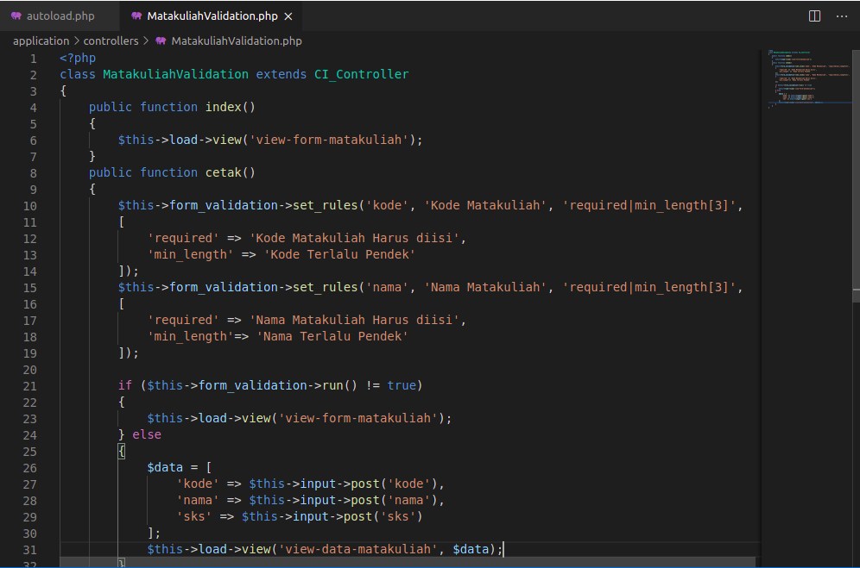

- Hasil URL

http://localhost/pustaka-booking/MatakuliahValidation

- Capture Hasil
